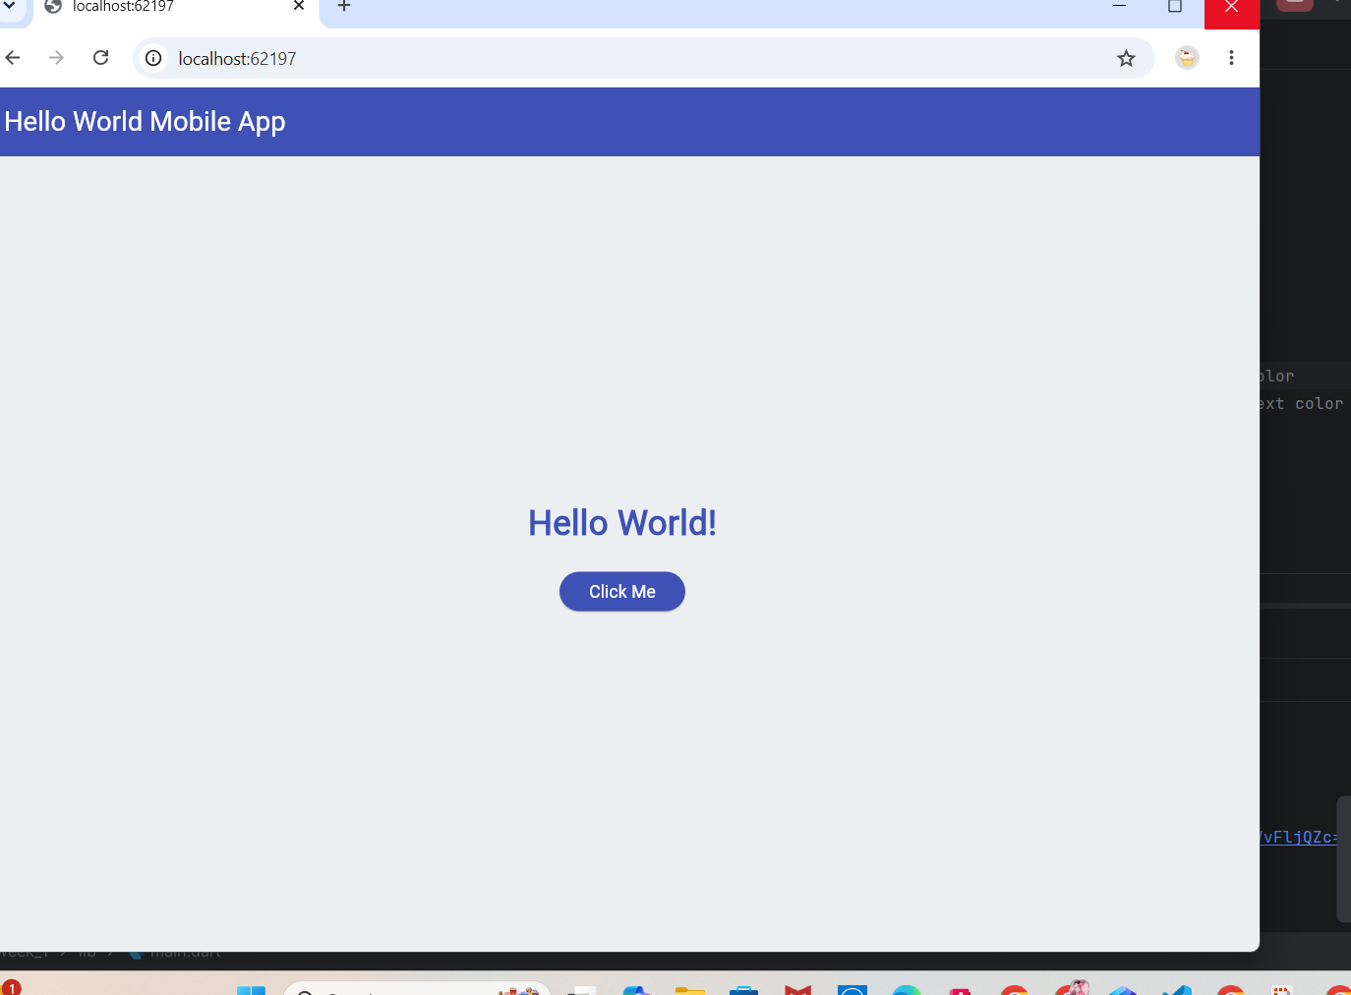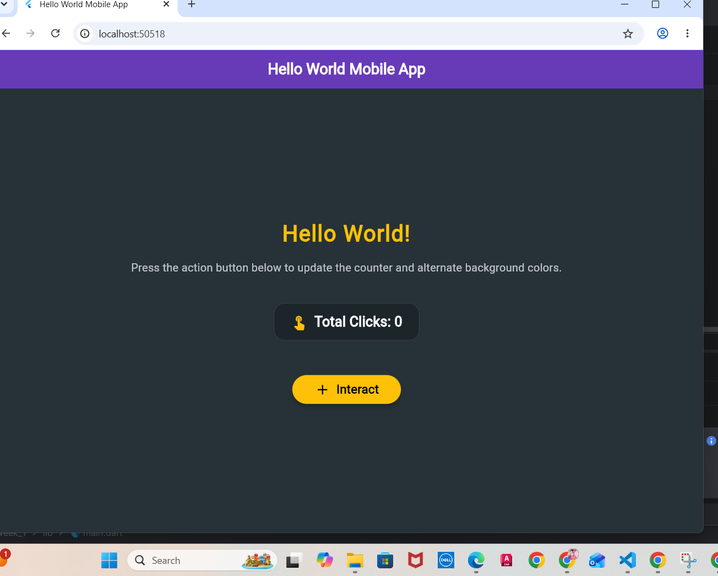

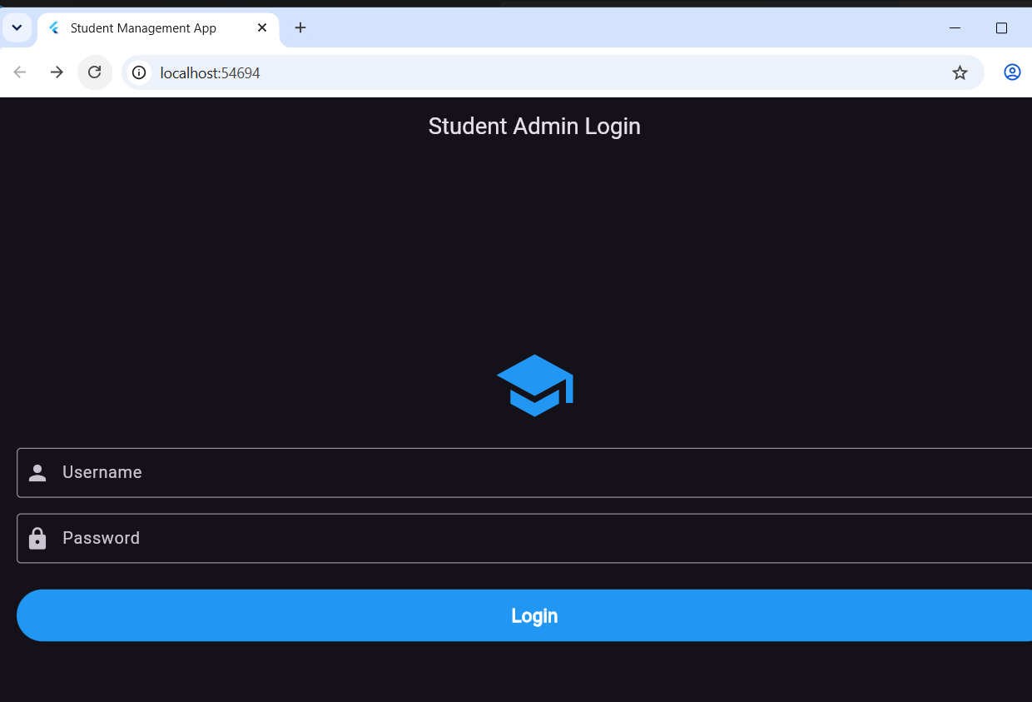

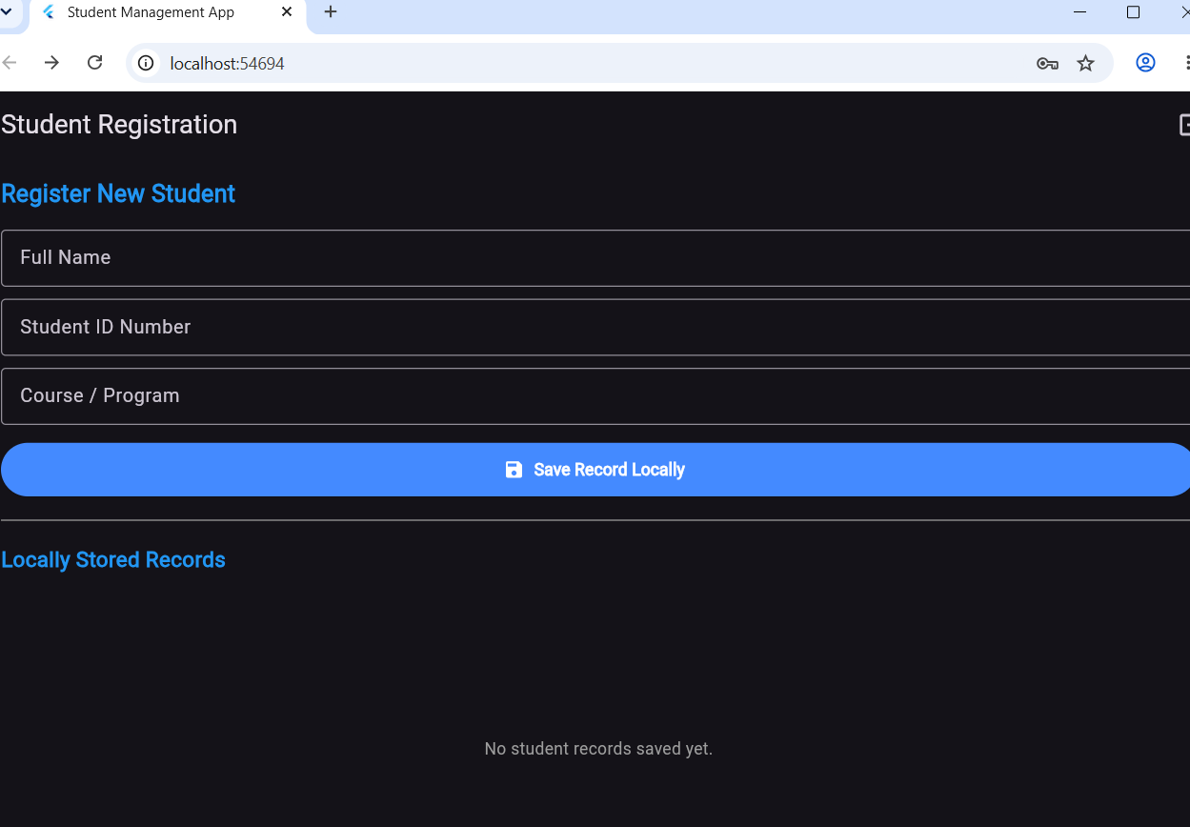

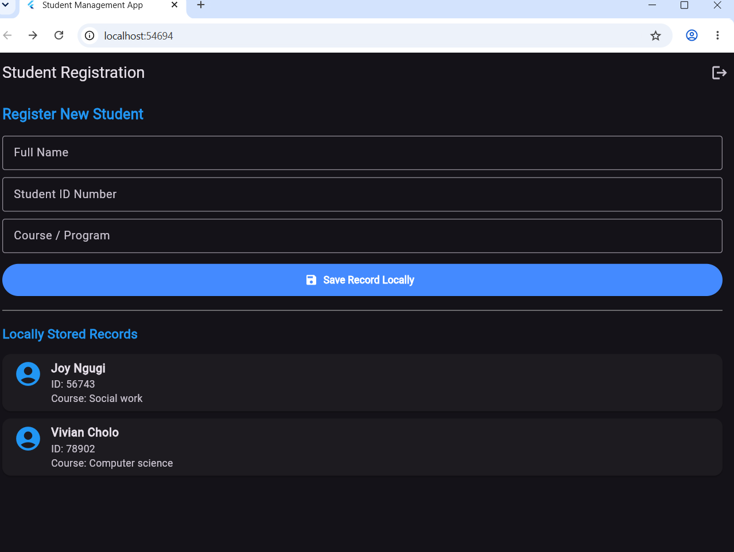

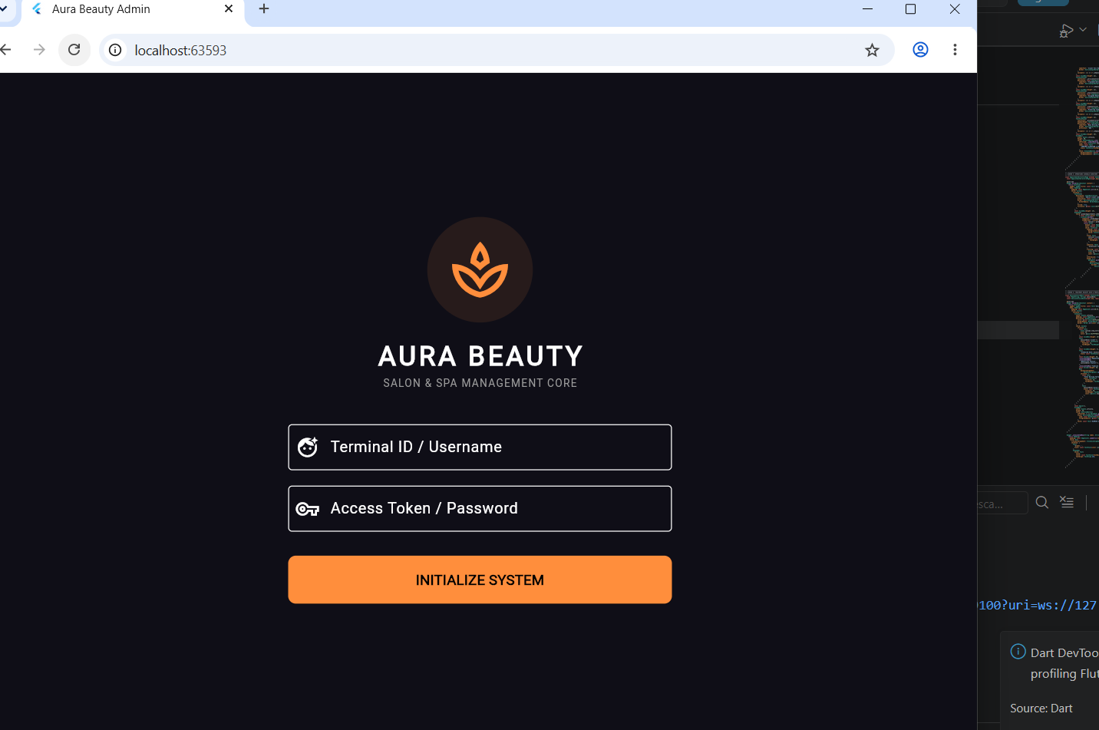

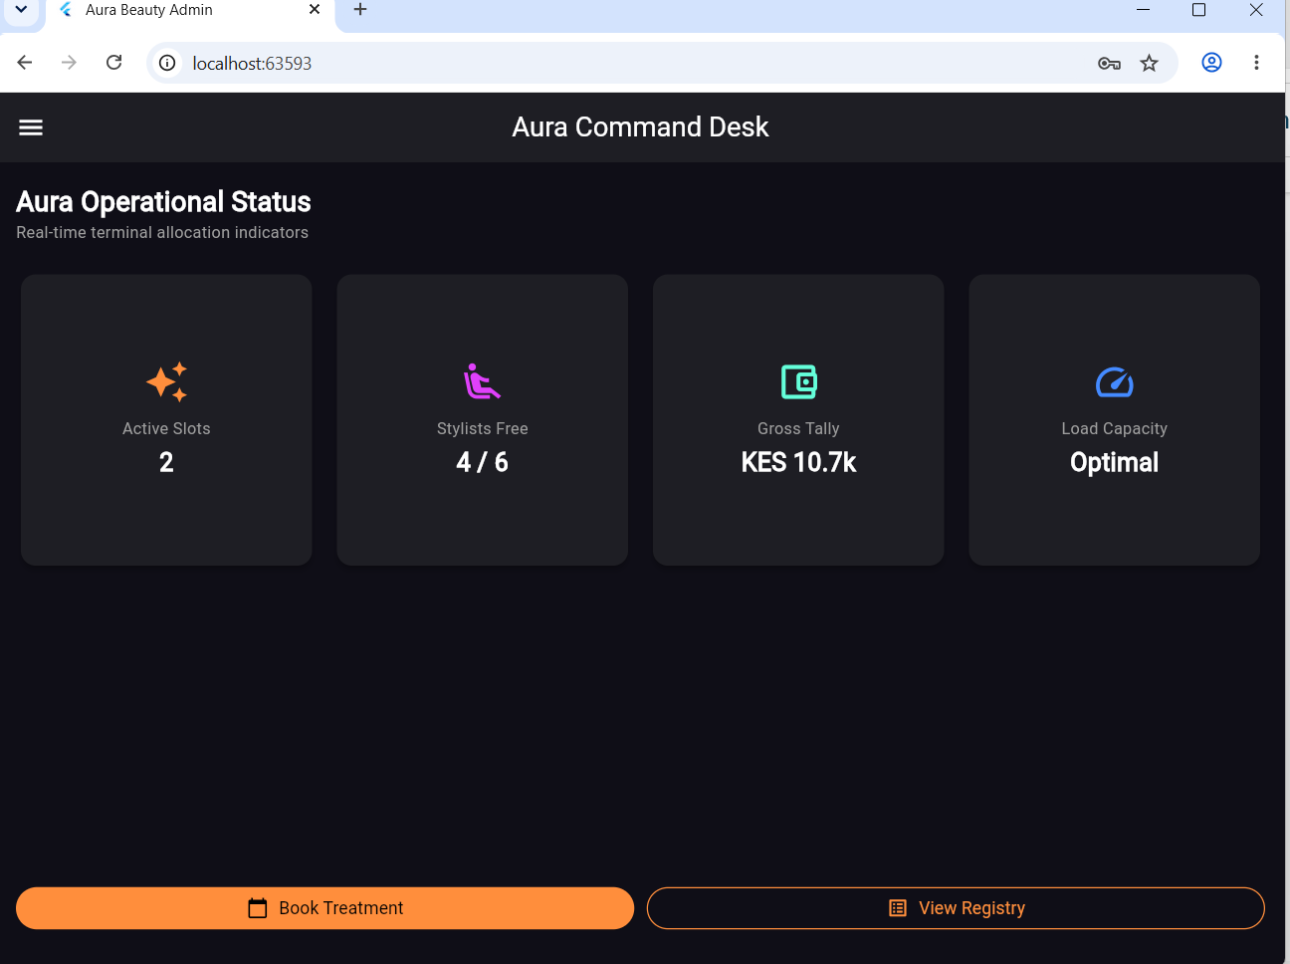

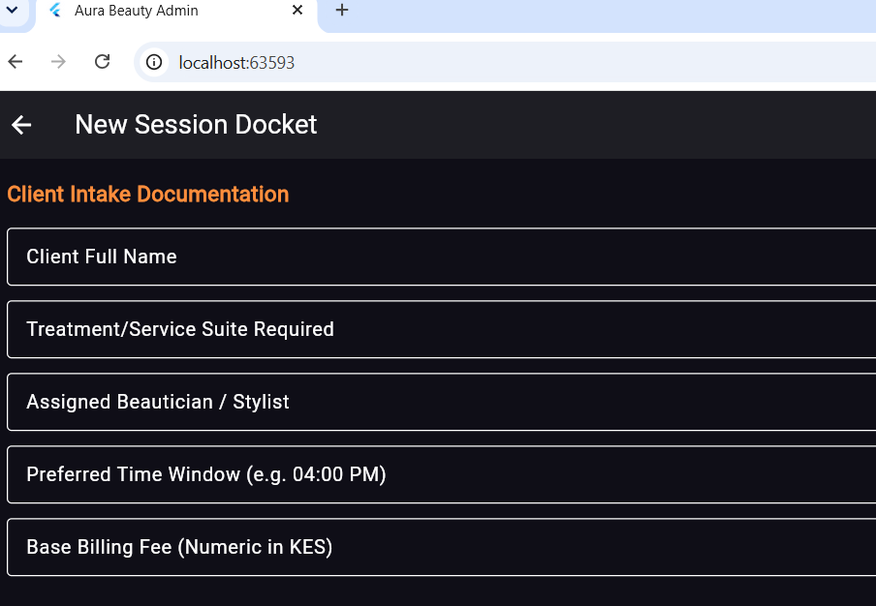

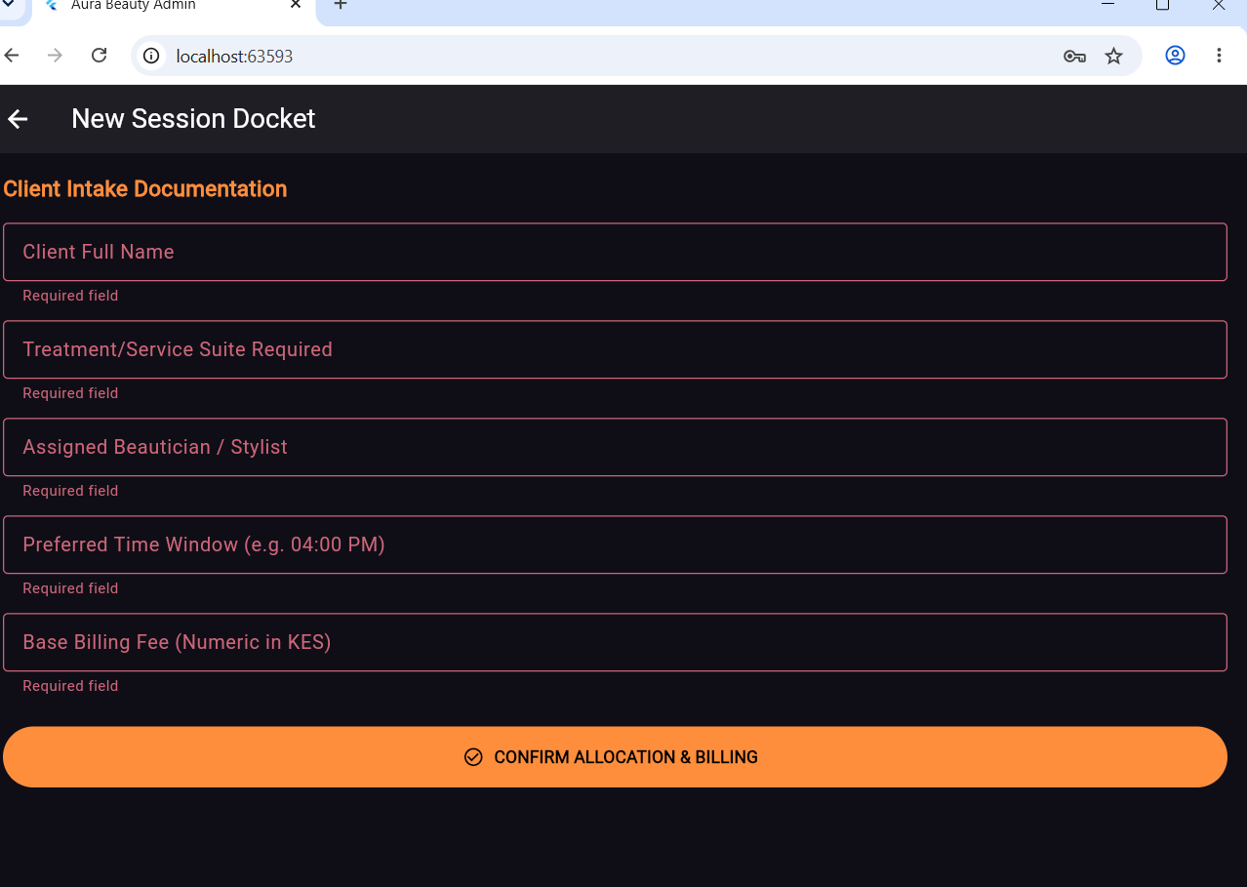

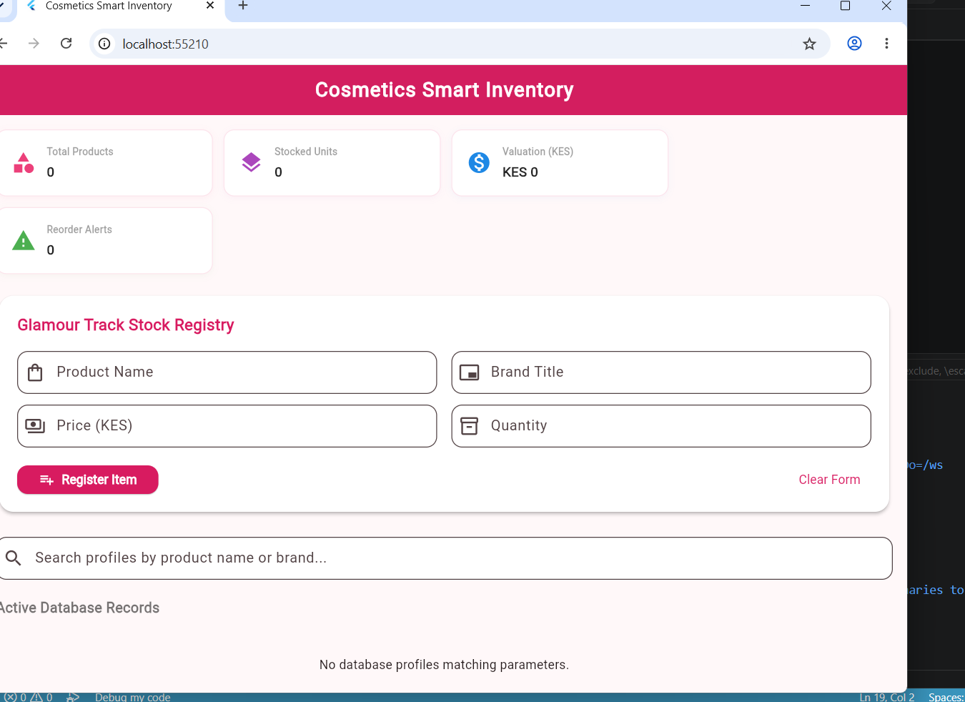

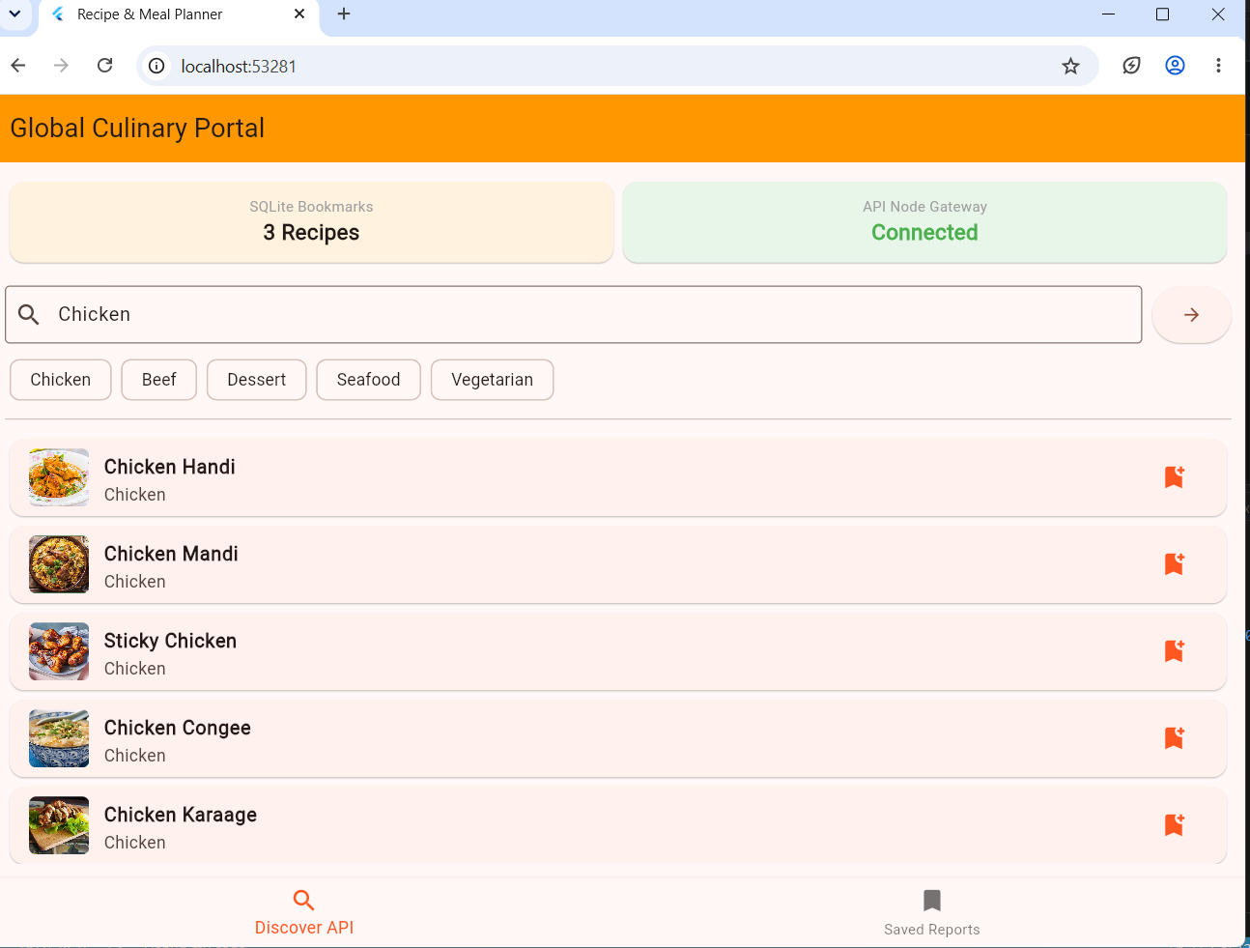

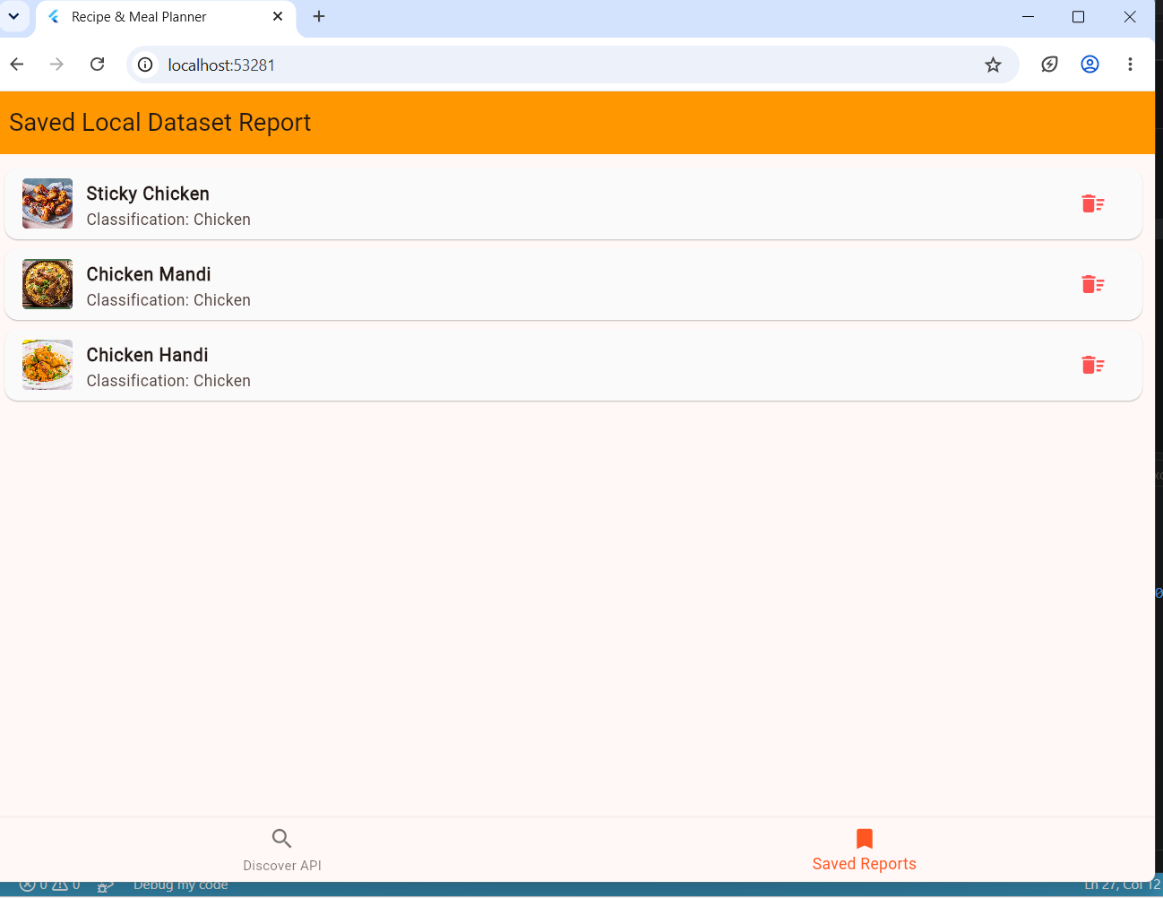

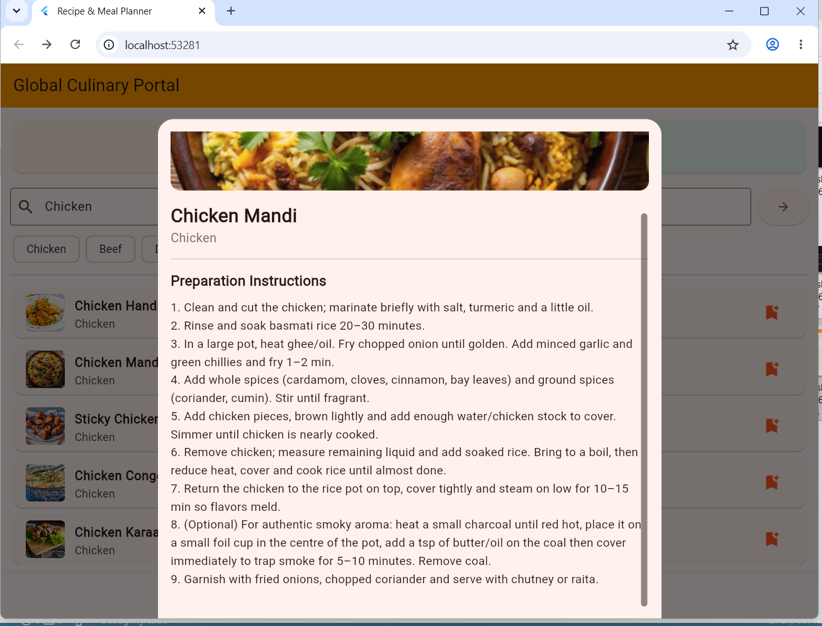

Assignment week 6
1.The network connection string
https://www.themealdb.com/api/json/v1/1/search.php?s=
2.Explain why it requires networking
Networking allows our app to dynamically fetch thousands of real-time recipes from a cloud database without bloating local device storage capacity.
3. Explain API’s and asynchronous applications
An Application Programming Interface (API) is a structured software intermediary and communication contract that allows two distinct, independent computer applications to exchange data and functionalities over a network.
In a standard client-server architecture, a REST API relies on uniform HTTP protocols such as GET and POST to accept requests from a frontend application tier, interact with a backend data tier, and return data in a standardized, cross-platform format like JSON. This eliminates the need for the client application to have direct access to or knowledge of the underlying database engine.
Asynchronous Application Execution is a programming paradigm where resource-intensive or unpredictable tasks such as network I/O operations and database queries are offloaded to a separate background execution thread rather than running on the main application thread.

